**Learn how to use the app for Admin**

Step 1:

* If you are not signed up- first sign up. Fill the required information. (This form data will get saved in the database)
* Qr code will get generate based on the form inputs and will get saved on qrcodes of our applications directory(../EToll/qrcodes/)

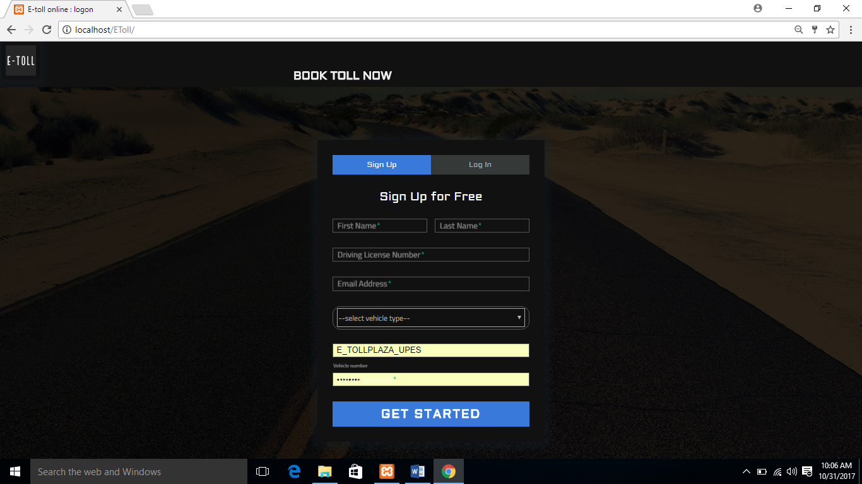

Step 2:

* Go to Direction widget and fill the first and second address as ‘From’ and ‘To’. If you want to pass from a particular location add the address through ’ADD’ button but in sequential manner.

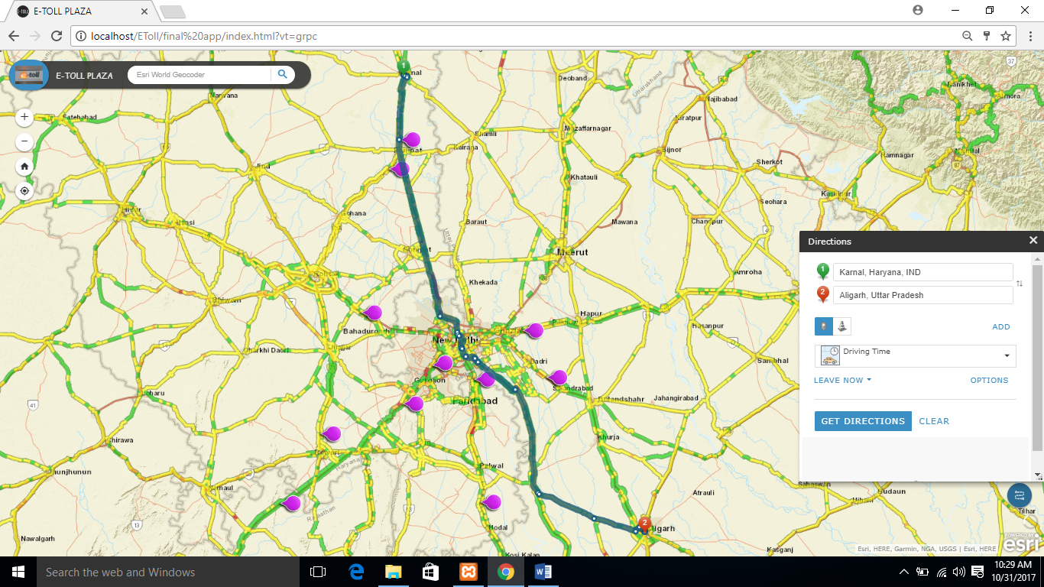

Zoom in &out

Toll plaza

To locate yourself on map

Direction widget

Step 3:

* Once you have selected the route, zoom in to clearly see which all toll plaza falls in your route. Then select each toll plaza by just clicking the symbol of oll plaza then click ‘Pay Toll’. It will lead you to the payment page.

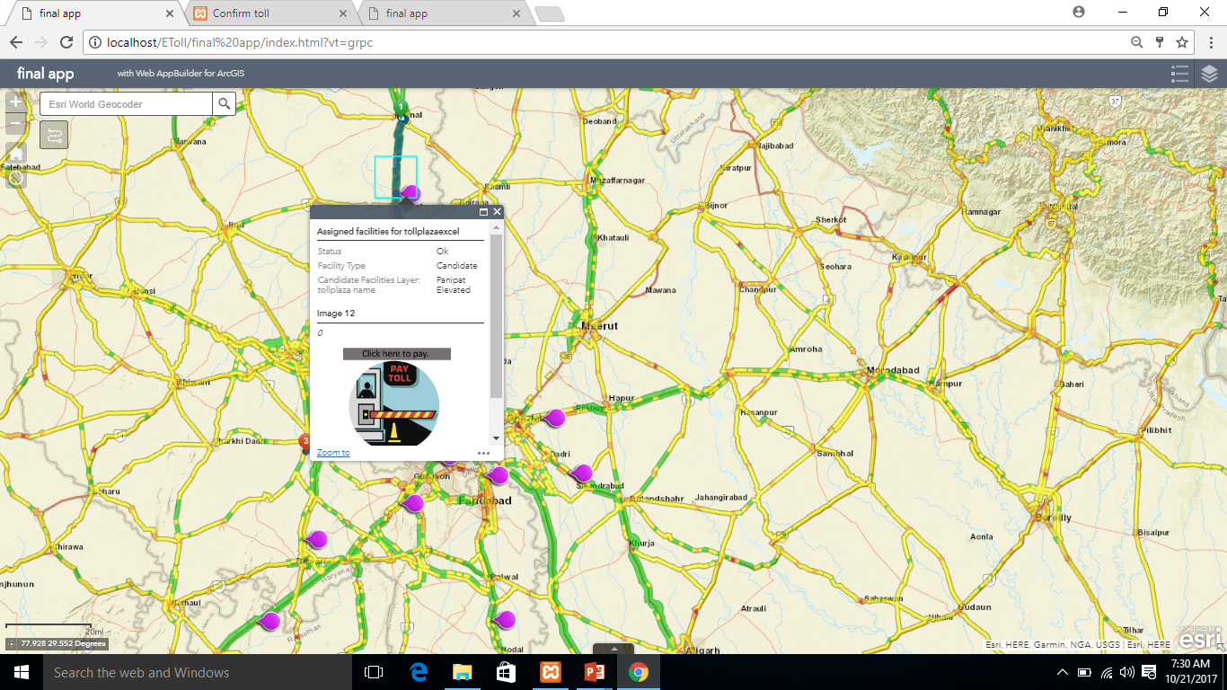

* If you want to select the rest toll, then click the ‘Select More’ option. It will redirect you to the map.

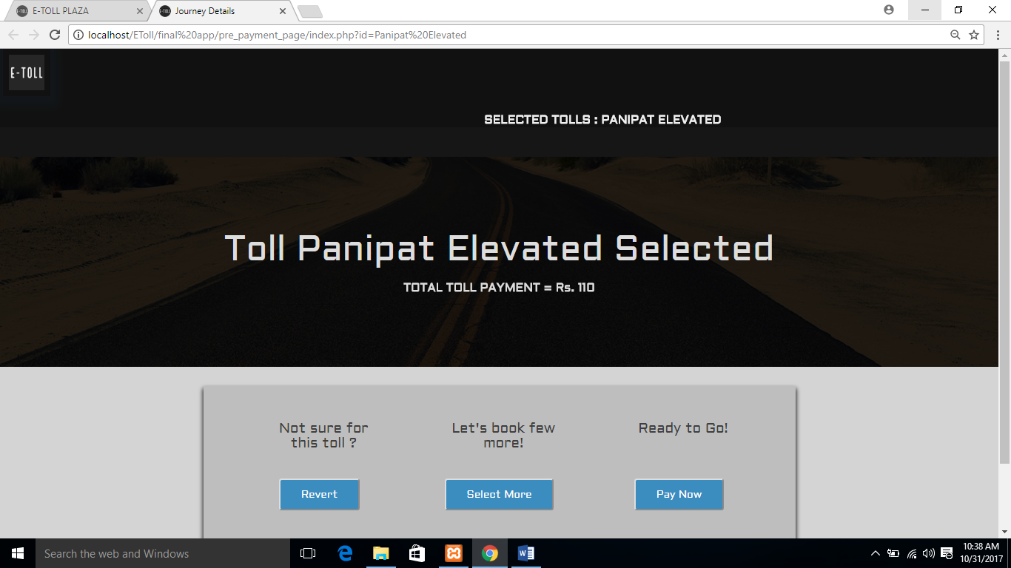

* Again click the other toll symbol then to the ‘Pay Toll’ and repeat till all the toll are select.
* If you want to unselect any toll just click ‘Revert’. It will lead you to the previously selected tolls.

Step 4:

* Once you done with the toll selection click the ‘Pay Now’ for the payment of all toll taxes.
* Choose the preferred mode of payment and fill the required information.

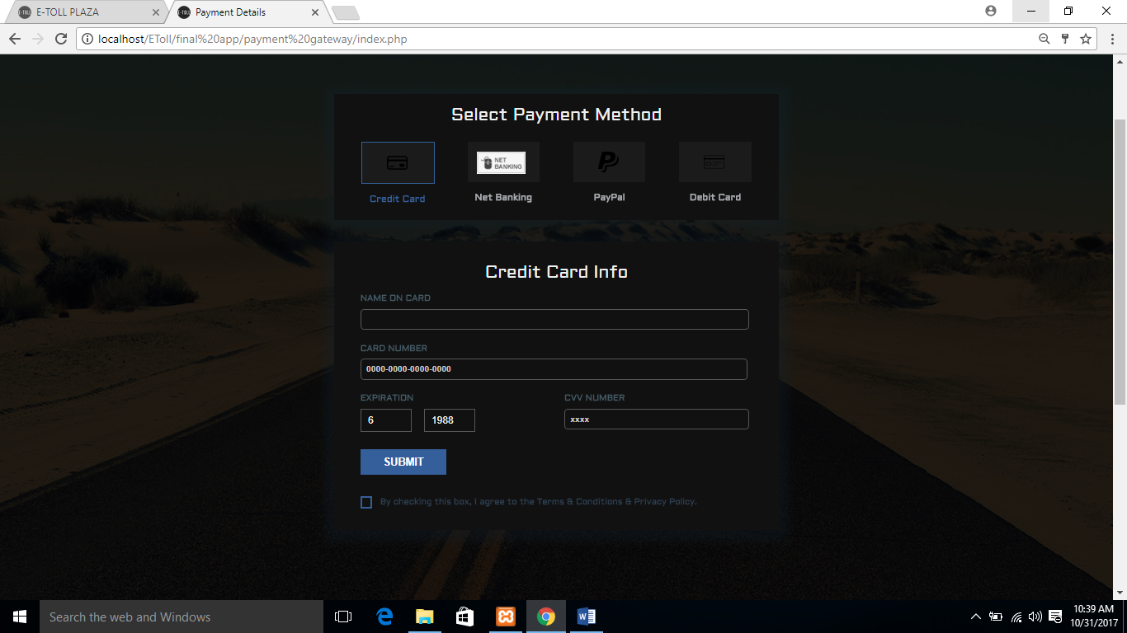

* Once the payment is successful you will receive the receipt vial mail.